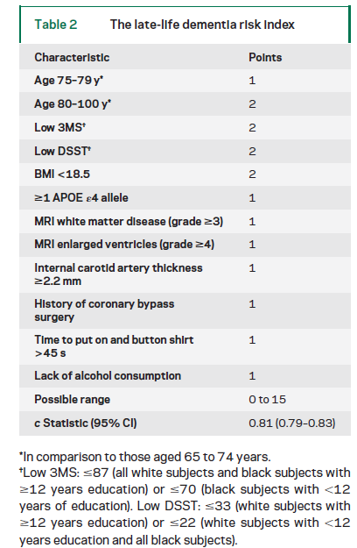

Predicting risk of dementia in older adults. The late-life dementia risk index

D. E. Barnes PhD, MPH*, et al., Neurology, 2009
Alzheimer’s Risk Factors

Whether a person over 65 is at high risk of developing Alzheimer's disease within six years
Predicted about half the cases of dementia that developed in a group of elderly people over a six year period.People with a score of 8 or higher are considered at high risk of developing dementia within the next six years. 3,375 people with an average age of 76 and no evidence of dementia. Over six years, 480 of the people developed dementia. 56% of these high scorers showed serious mental decline by the end of the study period. Of those scoring lower on the index, deemed at moderate or low risk, 23% were diagnosed with dementia. The index correctly classified 88 percent of the participants.
1 Age 75-85 1 pt
2 Age 85-100 2 pt
3 ≥ 1 ApoE4 allele 1 pt
4 Low 3MS ≤87 (all white subjects and black subjects with ≥ 12 years education) or ≤ 70 (black subjects with _12 years of education). 2 pt
5 Low DSST: ≤ 33 (white subjects with ≥ 12 years education) or ≥ 22 (white subjects with ≥ 12 years education and all black subjects) 2 pt
6 BMI below 18.5 2 pts
7 MRI white matter disease (grade >3) 1
8 MRI enlarged ventricles (grade >4) 1
9 Internal carotid artery thickness>2.2mm 1
10 History of coronary bypass surgery 1
11 Time to put on and button shirt >45 s 1
12 Lack of alcohol consumption 1

13 Possible range 0 to 15
c Statistic (95% CI) 0.81 (0.79–0.83)

